**Introduction**

Apnea is defined as the cessation of breathing and general causes include neurological problems, immature brainstem, brain infection, and enlarged tonsils and adenoids. The three main types are obstructive sleep apnea, central sleep apnea, and mixed sleep apnea. Common symptoms of sleep apnea include cyanosis and bradycardia. In serious cases, drugs can be given to stimulate the respiratory systems. However, in many cases, an apnea monitor is the solution.

**Method**

For the review, the focus is on researching infant monitor for central sleep apnea because is the most common condition. The instrumentation and usage of the movement monitor and cardiorespiratory monitor were discussed. Additionally, the safety warnings and tips for buying the right devices were also presented. With all the information gathered, the goal was to determine the best products available in the market.

**Result**

Two of the best products found are shown below. They offer extensive features in addition to the main one which is either movement tracking or heart rate monitoring. Furthermore, they are reliable in terms of sensitivity and accuracy, have long battery life, and loud alarm.

***Owlet Smart Sock Baby Monitor BabySense Video and Movement Monitor***

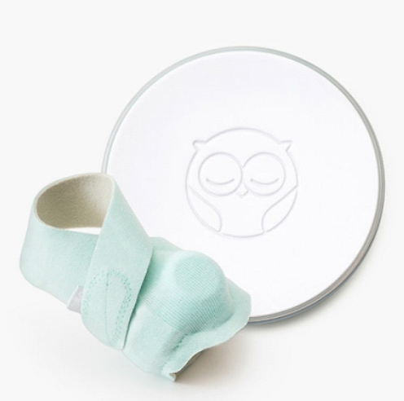 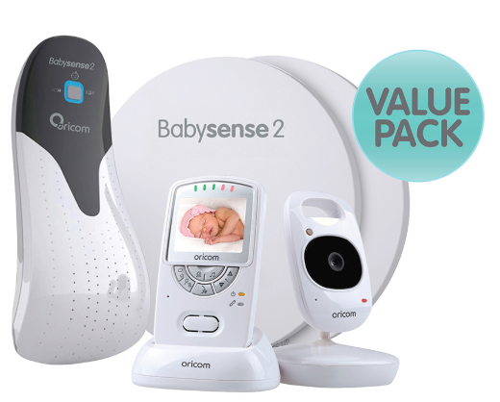

**Discussion**

The owlet smart sock offers oxygen level, breathing, and heart rate monitor. Additionally, results can be viewed in real-time monitoring app, and it also comes with a rechargeable and portable unit as well as an alert system for a price of $200. As for the BabySense, it has a video recorder, movement sensor pads, temperature monitor, timer, two ways audio, rechargeable unit, and also an alert system for the prices on $150. Even though it offers more features, the portability is lacking compared to Owlet Smart Sock.